|  |  |  |  |  |  |
| --- | --- | --- | --- | --- | --- |
| Date | 28-Nov-22 | | | Tester Name | Richard Belanger |
| Environment | Penfax - Test | | | Login used | TEST2 |
| Operating System | Windows | Version: | Update: | | |
| Software Used | Edge | Version: | Update: | | |
| Not Applicable | Version: | Update: | | |
| Release version | 22.4.1 | | | | |
| Title | M5.05 Vested Designated member with small benefit | | | | |
| Test Type | Regression | | | | |
| Test Scenario | Member will be Terminated and payment produced | | | | |
|  |  | | | | |
| Expected Results | Member will be Terminated and payment produced with correct taxes withheld | | | | |
| Pass/Fail | Pass | | | JIRA# | N/A |

Describe your steps with screenshots:

Member is Vested-Designated

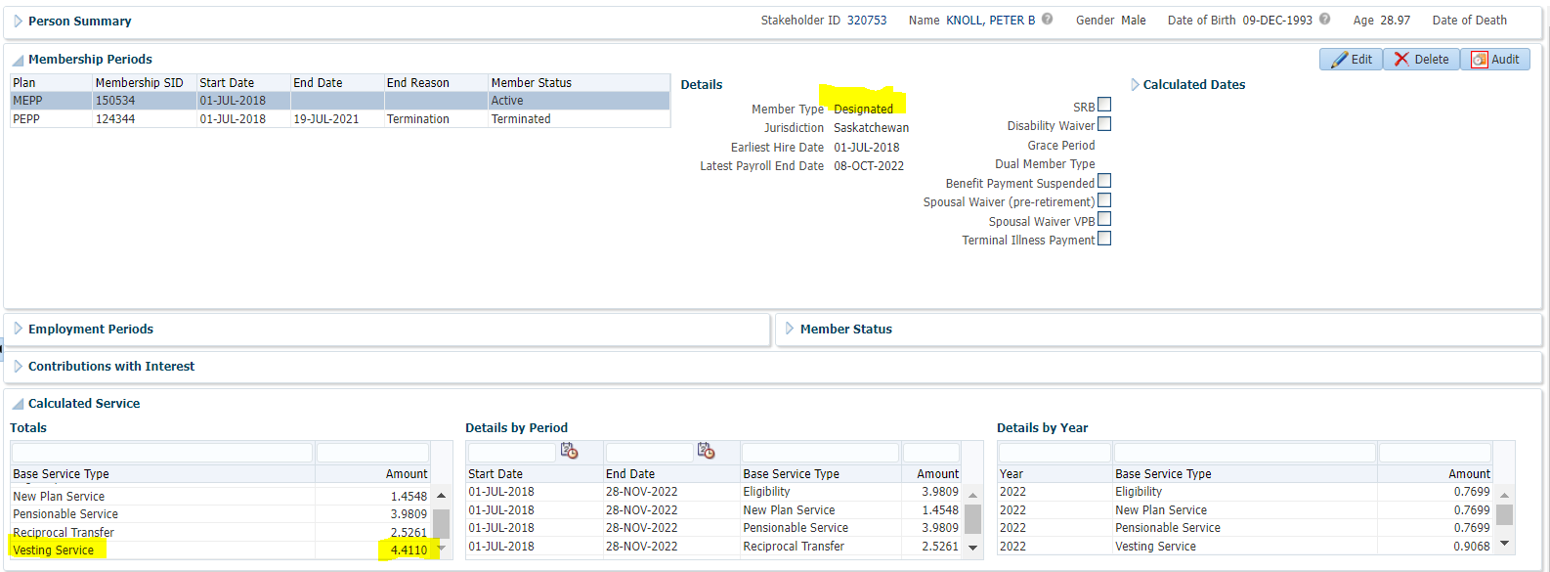

Terminate Member

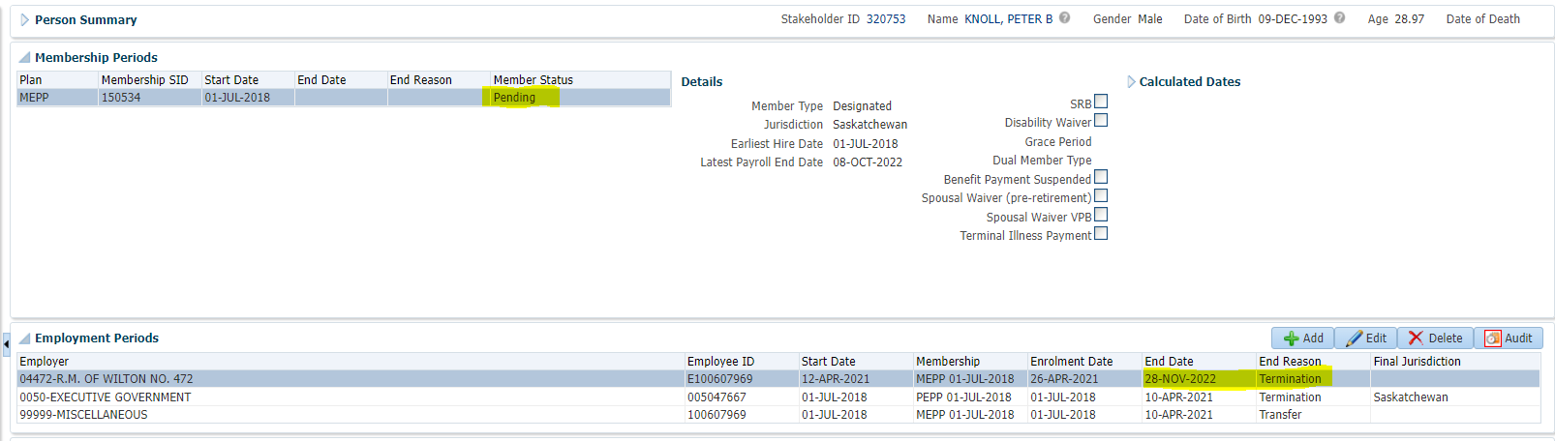

Member Profile>Benefit Calculation>Calculate

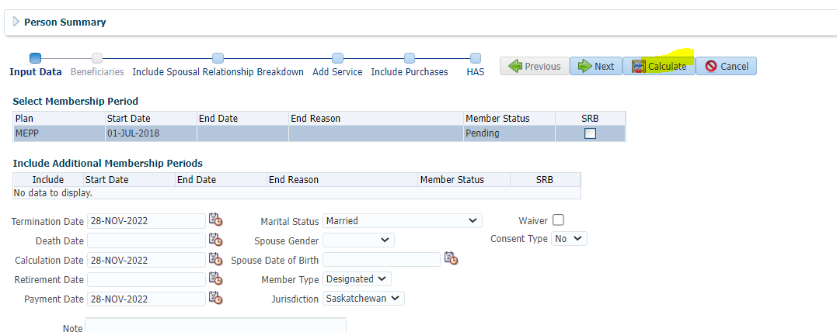

Member has a Small Benefit, not Locked-In>Processed

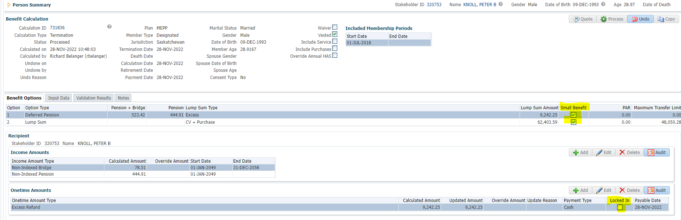

To Benefit Selection>Next

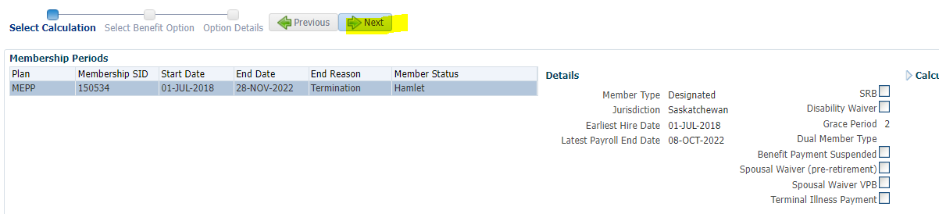

Choose Lump Sum line Add Payment Date>Next

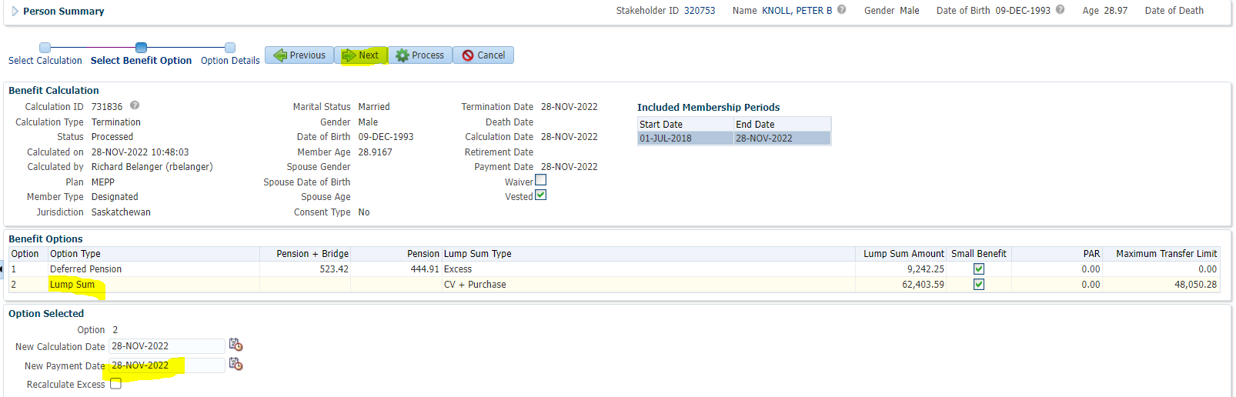

Send EXCESS Refund,Other Contributions Over Limit to Cash and Small Benefit CV

Send and Small Benefit Other Contributions to RRSP>Process

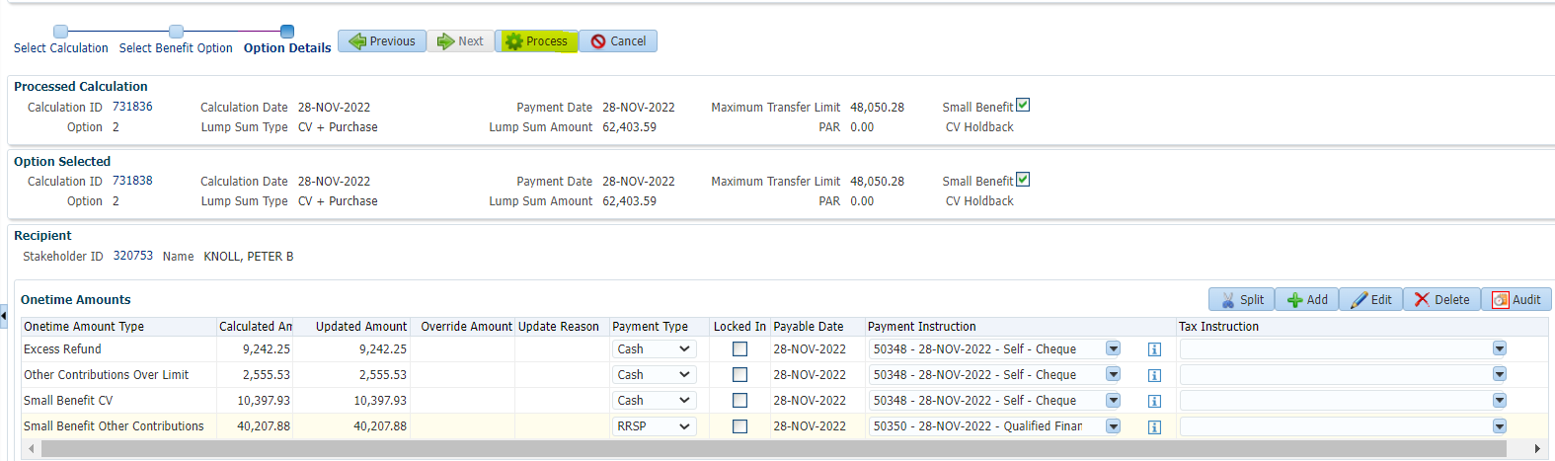

To Benefit Recipient>Submit the Payment lines for Approval>Approve>Authorize

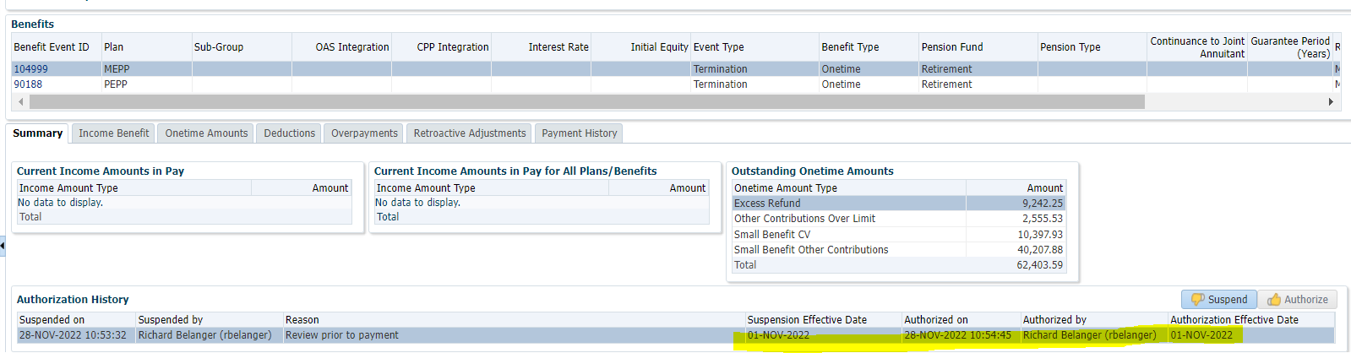

Payment processed via PENFAX Payment Production

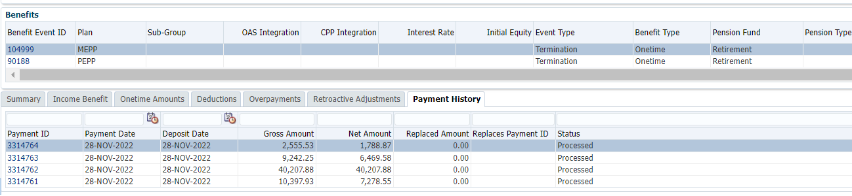

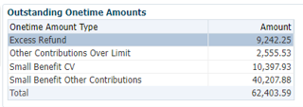

Tax Rates

0.00-4,999.99 = 10%

5,000.00- 14,999.99 = 20%

15,000.00+ = 30%

EXCESS Refund,Other Contributions Over Limit to Cash and Small Benefit CV

9242.25 + 2555.53 + 10397.88 = $22,195.66; This amount will be taxed at 30%

22195.66 x 30% = 6658.70; 22195.66 – 6568.70 = $15,536.96

**RRSP amounts not subject to Tax**

**$40,207.88**